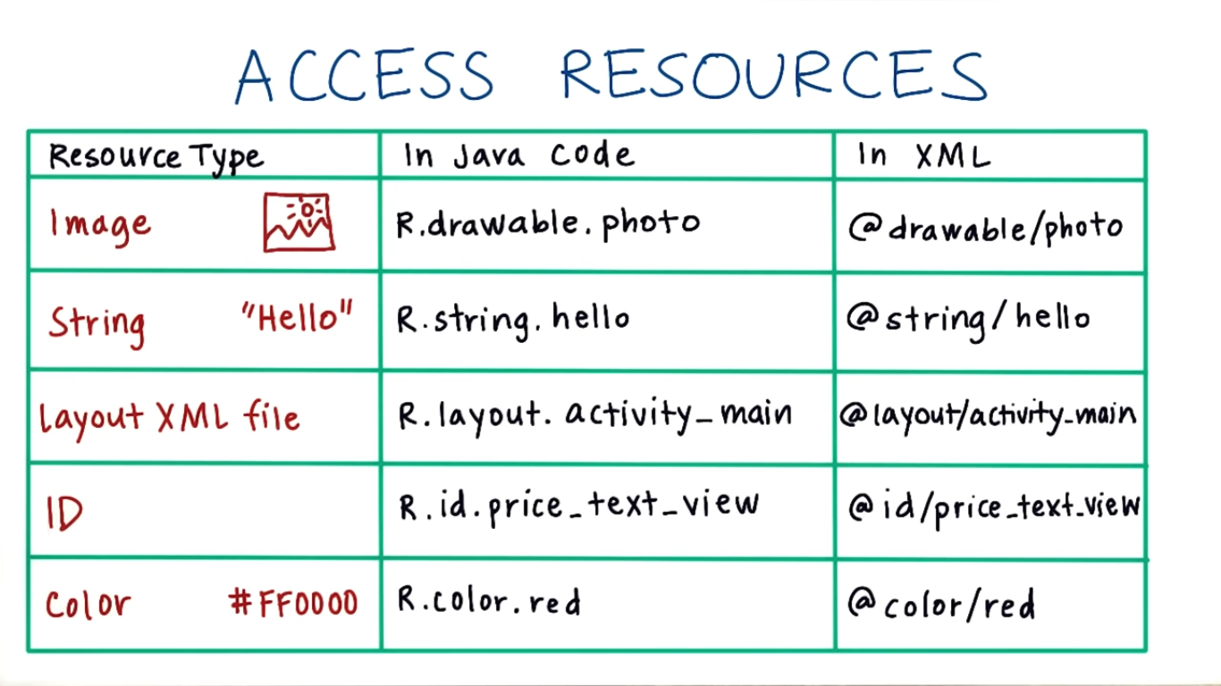

Create Object

New

Factory method

* Padding inside the view “android: padding”
* Margin outside the view “Android: layout_margin”
* Layout_gravity **Outside** gravity
* Gravity **Inside** gravity

Layout -> outside view relationship

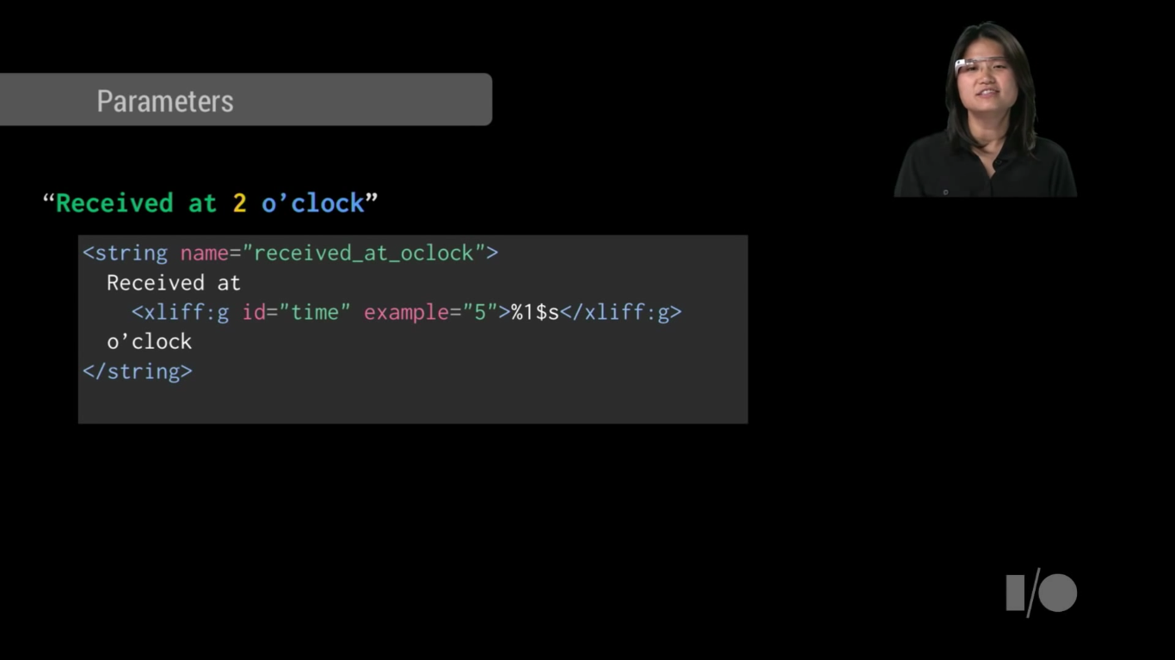This image is used when you pass parameter in middle of string or concatenate words

Style vs Theme

* Style on single view
* Theme on activity or app

**GNU** stands for “**G**NU's **N**ot **U**nix”.

**Unix** stands for **Uni**ple**x**ed Information and Computer Systems.

**Build Tool**

* are programs that automate the creation of executable applications from source code(eg. .apk for android app). Building incorporates compiling,linking and packaging the code into a usable or executable form.

**build automation**

* In small projects, developers will often manually invoke the build process. This is not practical for larger projects, where it is very hard to keep track of what needs to be built, in what sequence and what dependencies there are in the building process. Using an automation tool allows the build process to be more consistent.

**adb**

* Android Debug Bridge

**Android App**

* Collection of Connected Components works each other with android framework

**Four Types of Component Registered on android Manifst**

1. **Activity**
2. **Services**
3. **Content Provider**
4. **Broad Cast Receiver**

**Type of View: UI Components**

There are two major categories of views. The first type are UI components that are often interactive. Here are a few examples:

| **Class Name** | **Description** |
| --- | --- |
| [TextView](https://developer.android.com/reference/android/widget/TextView.html) | Creates text on the screen; generally non interactive text. |
| [EditText](https://developer.android.com/reference/android/widget/EditText.html) | Creates a text input on the screen |
| [ImageView](https://developer.android.com/reference/android/widget/ImageView.html) | Creates an image on the screen |
| [Button](https://developer.android.com/reference/android/widget/Button.html) | Creates a button on the screen |
| [Chronometer](https://developer.android.com/reference/android/widget/Chronometer.html) | Create a simple timer on screen |

The [android.widget](https://developer.android.com/reference/android/widget/package-summary.html) package contains a list of *most* of the UI view classes available to you.

**Type of View : Container View**

The second are views called "Layout" or "Container" views. They extend from a class called [ViewGroup](https://developer.android.com/reference/android/view/ViewGroup.html). They are primarily responsible for containing a group of views and determining where they are on screen. What do I mean by "containing a group of views?". I mean that a view will be nested inside the tag of another view, like below:

| **Class Name** | **Description** |
| --- | --- |
| [LinearLayout](https://developer.android.com/reference/android/widget/LinearLayout.html) | Displays views in a single column or row. |
| [RelativeLayout](https://developer.android.com/reference/android/widget/RelativeLayout.html) | Displays views positioned relative to each other and this view. |
| [FrameLayout](https://developer.android.com/reference/android/widget/FrameLayout.html) | A ViewGroup meant to contain a single child view. |
| [ScrollView](https://developer.android.com/reference/android/widget/ScrollView.html) | A FrameLayout that is designed to let the user scroll through the content in the view. |
| [ConstraintLayout](https://developer.android.com/reference/android/support/constraint/ConstraintLayout.html) | This is a newer viewgroup; it positions views in a flexible way. We’ll be exploring constraint layout later in the lesson. |

### The R Class

When your application is compiled the [R](https://developer.android.com/reference/android/R.html) class is generated. It creates constants that allow you to dynamically identify the various contents of the res folder, including layouts. To learn more, check out the documentation about [resources](https://developer.android.com/guide/topics/resources/accessing-resources.html).

Short cuts

Android Comment -> Ctrl + /

Arrange XML -> Ctrl + Alt + L

Prediction -> Ctrl + Space

Ctrl + O -> show the available methods to override

ALT + Insert -> automatically “Generate a method (Getters, Setters, Constructors, toString, etc..)”. On Windows

@+id/tv_toy_names

@ -> look at resources

+ -> create if doesn’t exist

id -> create id not string, style nor image

ConstraintLayout

* Special kind of layout uses complex constrain on child views to allow for dynamic layoutsrespect different window sizes layouts

Handling different screen -> Using **Infer Constraints “inference”**

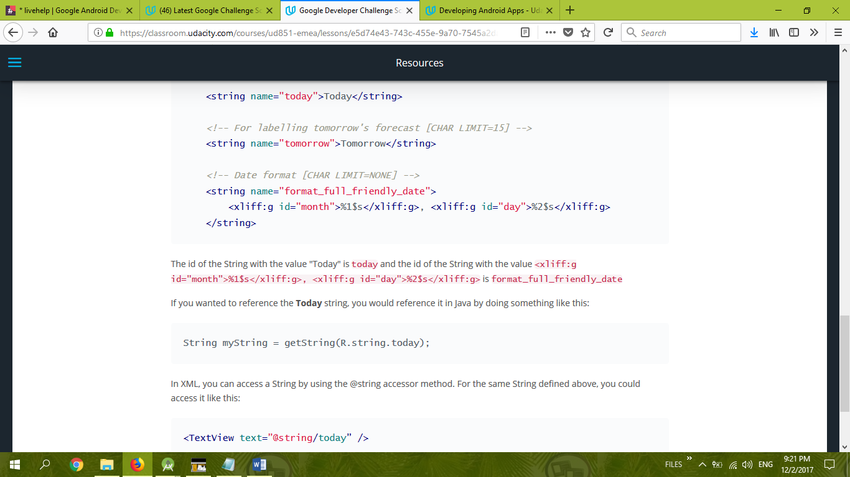

Menu

@Override  
public boolean onCreateOptionsMenu(Menu menu) {  
 getMenuInflater().inflate(R.menu.*main*,menu);  
 return true;  
}

@Override  
public boolean onOptionsItemSelected(MenuItem item) {  
 int menuItemThatWasSelected = item.getItemId();  
 if(menuItemThatWasSelected == R.id.*action_search*)  
 {  
 Context context = MainActivity.this;  
 String message = "Search clicked";  
 Toast.*makeText*(context,message,Toast.*LENGTH_LONG*).show();  
 }  
 return super.onOptionsItemSelected(item);  
}

URL

public static URL buildUrl(String githubSearchQuery) {//Metod in class NetworkUtils.java  
 // *TODO (1) Fill in this method to build the proper Github query URL* Uri builtUri = Uri.*parse*(*GITHUB_BASE_URL*).buildUpon()  
 .appendQueryParameter(*PARAM_QUERY*, githubSearchQuery)  
 .appendQueryParameter(*PARAM_SORT*, *sortBy*)  
 .build();  
 URL url = null;  
 try {  
 url = new URL(builtUri.toString());  
 } catch (MalformedURLException e) {  
 e.printStackTrace();  
 }  
 return url;  
}

//MainActivity

private EditText mSearchBoxEditText;

private TextView mUrlDisplayTextView;

private TextView mSearchResultsTextView;

protected void onCreate(Bundle savedInstanceState) {

super.onCreate(savedInstanceState);

setContentView(R.layout.activity_main);

mSearchBoxEditText = (EditText) findViewById(R.id.et_search_box);

mUrlDisplayTextView = (TextView) findViewById(R.id.tv_url_display);

mSearchResultsTextView = (TextView) findViewById(R.id.tv_github_search_results_json);

}

private void makeGithubSearchQuery() {

String githubQuery = mSearchBoxEditText.getText().toString();

URL githubSearchUrl = NetworkUtils.buildUrl(githubQuery);

mUrlDisplayTextView.setText(githubSearchUrl.toString());

}

Implicit intent

* Like open link on any browser you don’t know where to go

Explicit intent

* From activity to another you know where exactly to go usually on same app

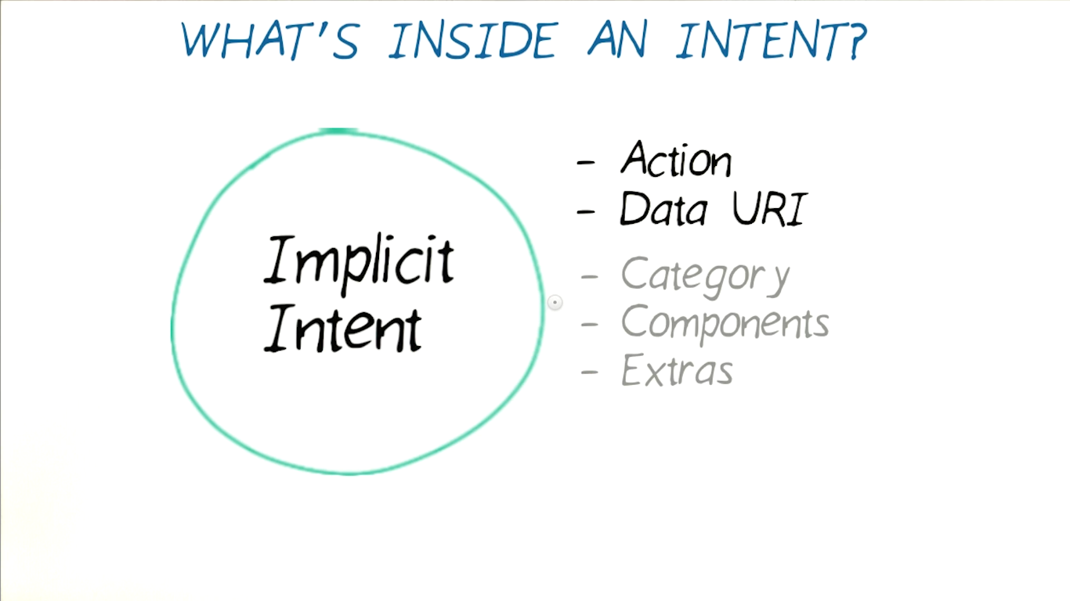

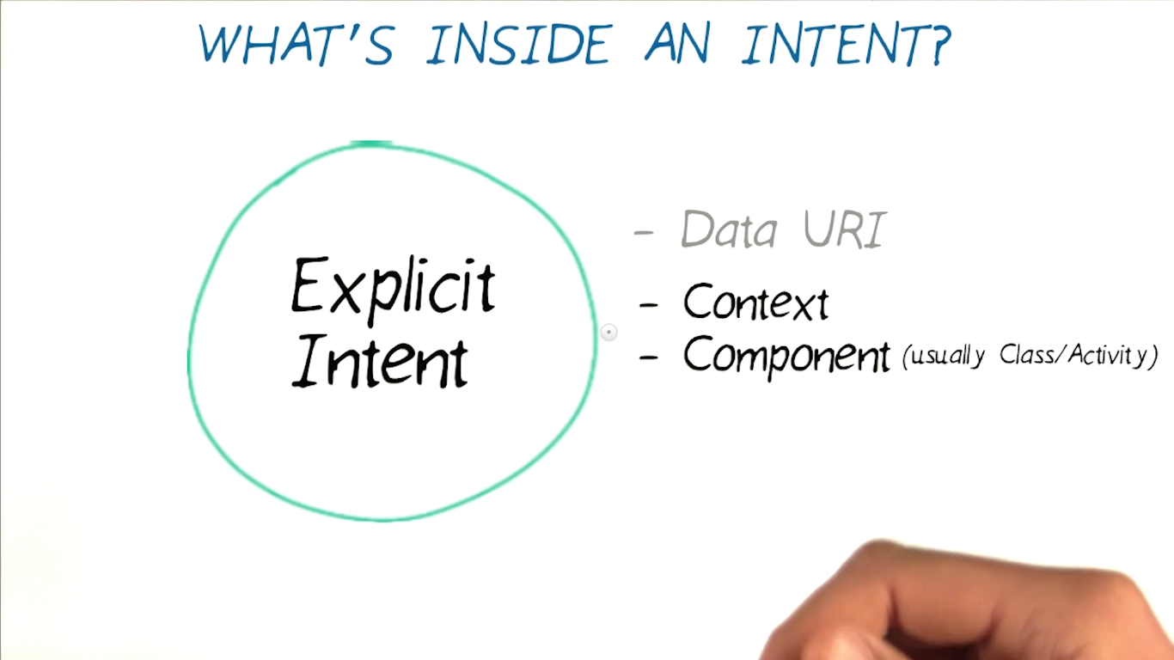

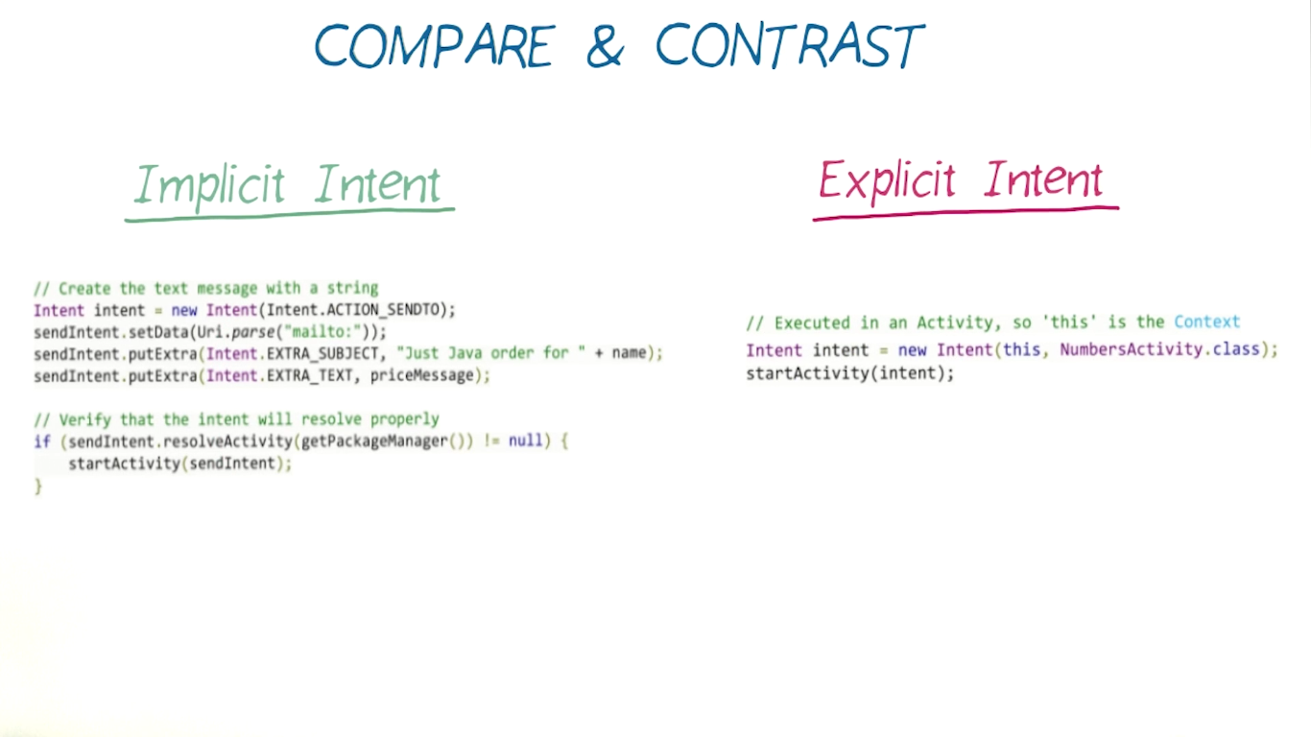

IMPLICIT INTENT

// Create the text message with a string  
Intent sendIntent = new Intent();  
sendIntent.setAction(Intent.ACTION_SEND);  
sendIntent.putExtra(Intent.EXTRA_TEXT, textMessage);  
sendIntent.setType("text/plain");  
  
// Verify that the intent will resolve to an activity  
if (sendIntent.resolveActivity(getPackageManager()) != null) {  
    startActivity(sendIntent);  
}

EXPLICIT INTENT

// Executed in an Activity, so 'this' is the [Context](https://developer.android.com/reference/android/content/Context.html)  
// The fileUrl is a string URL, such as "http://www.example.com/image.png"  
Intent downloadIntent = new Intent(this, DownloadService.class);  
downloadIntent.setData([Uri.parse](https://developer.android.com/reference/android/net/Uri.html" \l "parse(java.lang.String))(fileUrl));  
startService(downloadIntent);

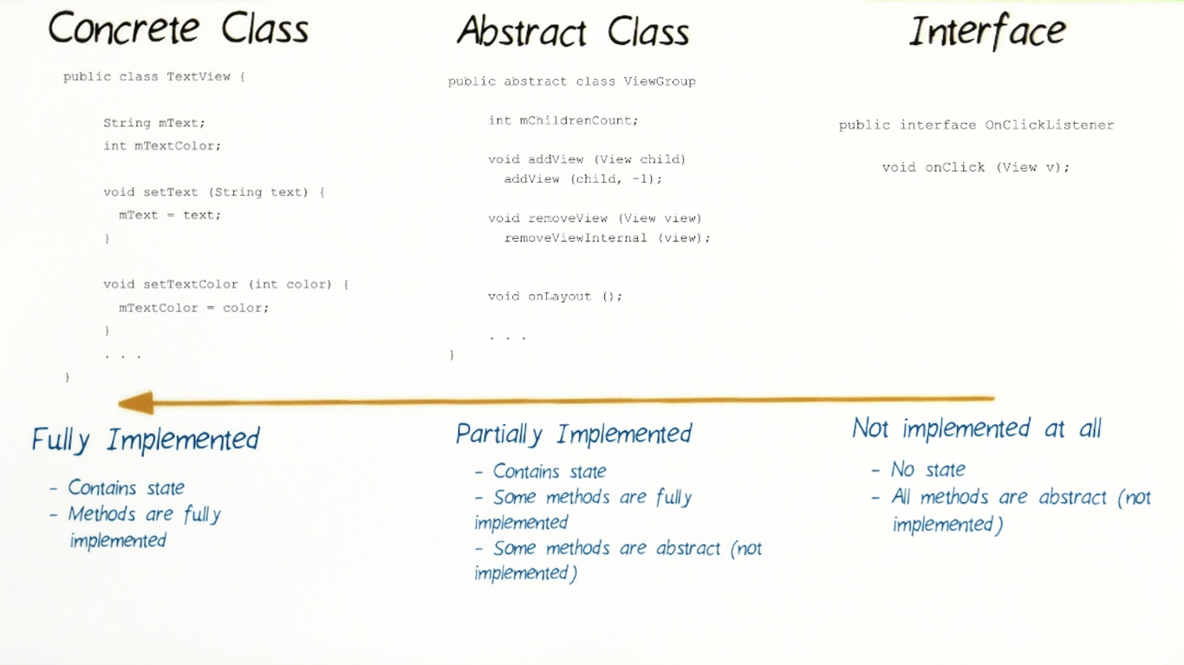

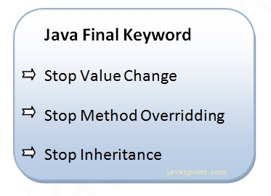

**Static**

1. Java static variable

* The static variable gets memory only once in class area at the time of class loading.
* Java static property is shared to all objects.

1. Java static method If you apply static keyword with any method, it is known as static method.
   * A static method belongs to the class rather than object of a class.
   * A static method can be invoked without the need for creating an instance of a class.
   * static method can access static data member and can change the value of it.
2. Java static block
   * Is used to initialize the static data member.
   * It is executed before main method at the time of classloading.

# Restrictions for static method There are two main restrictions for the static method. They are:

* The static method **cannot** use non-static data member or call non-static method directly.
* **this** and **super** cannot be used in static context.

An empty interface is known as tag or marker interface.

Interface

* can’t instantiate an interface in java
* **full** **abstraction**
* class **implements** interface, but an interface **extends** another interface.
* Interface can’t be declared as **private**, **protected** or transient
* Methods are by default **abstract** and **public**
* Variables are by default **public**, **static** and **final**
* Interface **variables must be initialized at the time of declaration** otherwise compiler will throw an error.
* Class can implement any number of interfaces
* If there are **two or more same methods** in two interfaces and a class implements both interfaces, implementation of the method once is enough
* A class cannot implement two interfaces that have methods with same name but different return type.
* Variable names conflicts can be resolved by interface name.

Advantages of interface in java

* Without bothering about the implementation part, we can achieve the security of implementation
* In java, [**multiple inheritance**](https://beginnersbook.com/2013/05/java-multiple-inheritance/) is not allowed, however you can use interface to make use of it as you can implement more than one interface.

**Object Oriented Approach OOP**

* **Abstraction**
  + **show only “relevant” data and “hide” unnecessary details of an object from the user.**
* **Encapsulation** 
  + - **binding (ربط) object state(fields) and behavior (methods) together. If you are creating class, you are doing encapsulation.**
    - The idea of encapsulation is to keep classes separated and prevent them from having tightly coupled with each other.
    - The whole idea behind encapsulation is to **hide the implementation details from users.** If a **data member is private it means it can only be accessed within the same class**. No outside class can access private data member (variable) of other class. But you can use public setter and getters to accsess
  + Binding the data with the code that manipulates it.
  + It keeps the data and the code safe from external interference
    - Encapsulated code should have following characteristics:
      * Everyone knows how to access it.
      * Can be easily used regardless of implementation details.
      * There shouldn’t any side effects of the code, to the rest of the application.
* **Inheritance**
* **The process by which one class acquires (اكتساب)the properties and functionalities of another class is called** [**inheritance**](https://beginnersbook.com/2013/03/inheritance-in-java/)**.**
  + Inheritance is the mechanism by which an object **acquires** the some/all properties of another object.
  + It supports the concept of hierarchical classification.
* **Polymorphism**
  + - **allows us to perform a single action in different ways.** For example, let’s say we have a class Animal that has a method animalSound(), here we cannot give implementation to this method as we do not know which Animal class would extend Animal class. So, we make this method abstract like this:
    - Polymorphism could be static and dynamic both. Method **Overloading is static polymorphism while, Method overriding is dynamic polymorphism.**
  + Polymorphism means to process objects differently based on their data type.
  + In other words, it means, one method with multiple implementation, for a certain class of action. And which implementation to be used is decided at runtime depending upon the situation (i.e., data type of the object)
  + This can be implemented by designing a generic interface, which provides generic methods for a certain class of action and there can be multiple classes, which provides the implementation of these generic methods.
* **Overloading** in simple words means more than one method having the same method name that behaves differently based on the arguments passed while calling the method. This called static because, which method to be invoked is decided at the time of compilation
* **Overriding** means a derived class is implementing a method of its super class. The call to overriden method is resolved at runtime, thus called runtime polymorphism

**Generalization** is the process of extracting shared characteristics from two or more classes, and combining them into a generalized superclass.

**specialization** means creating new subclasses from an existing class

Android Activity Life Cycle

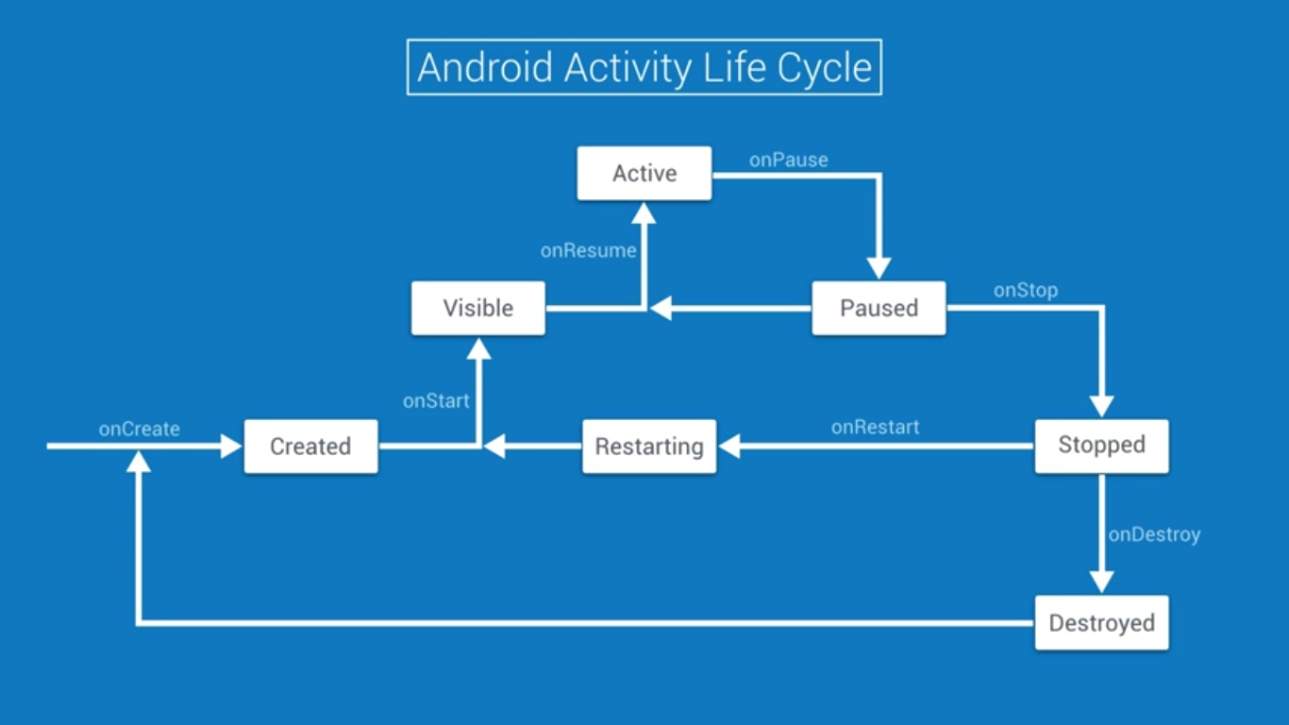

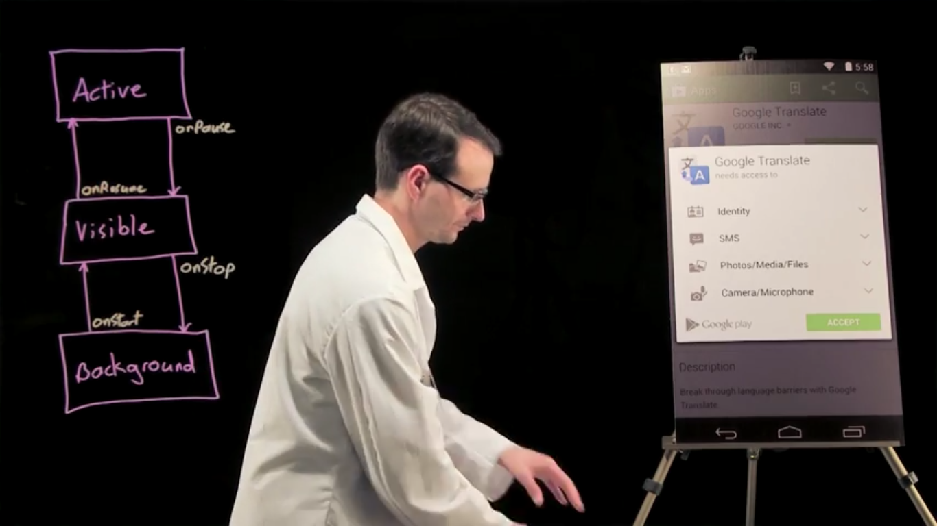

**Event Listener**

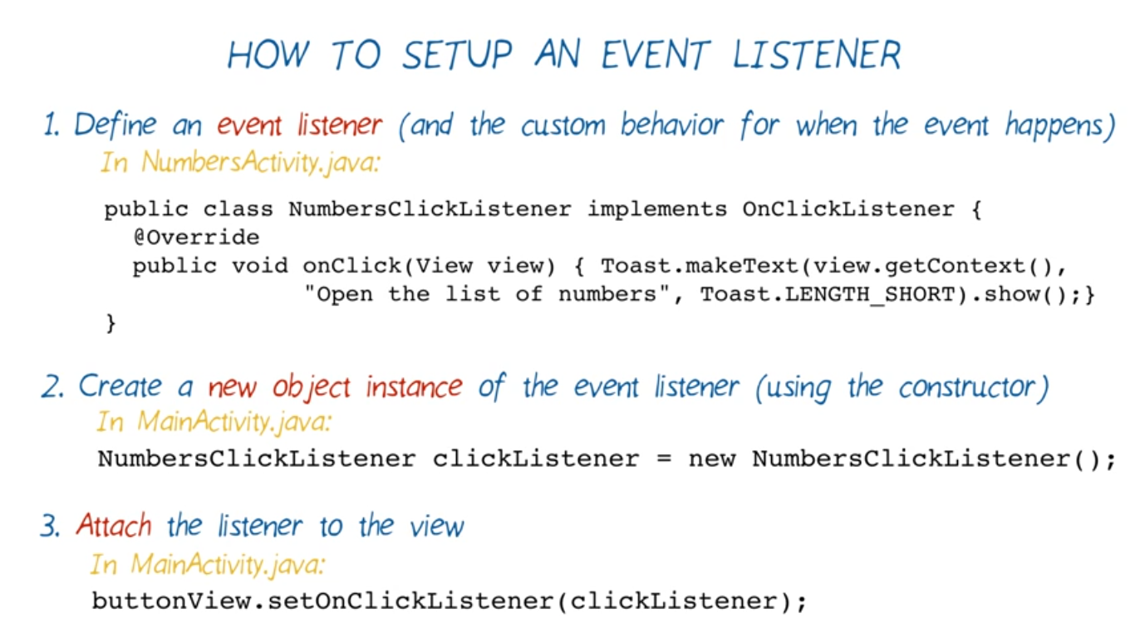

**Event Listener in one line**

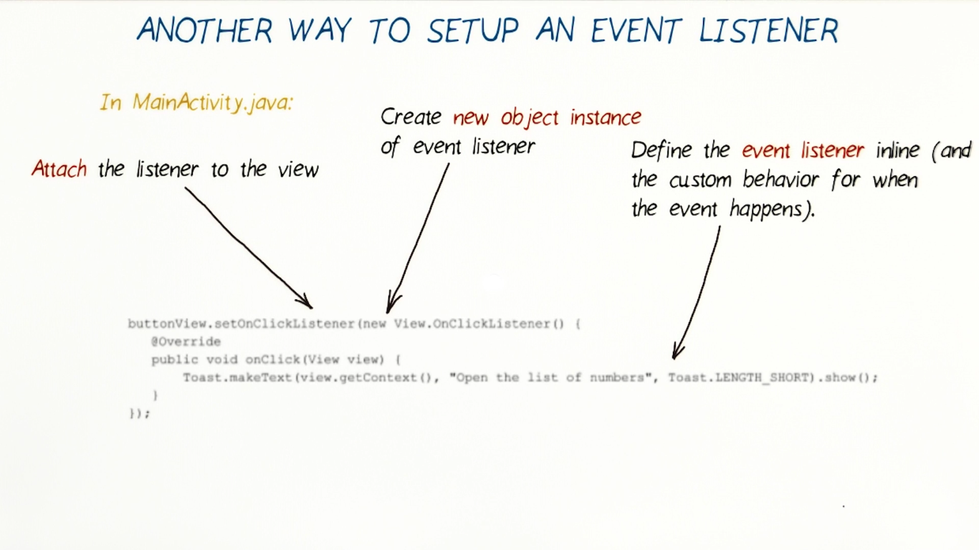

**OnClickListener vs onClick**

You might be wondering why we're going through all the trouble of creating an anonymous subclass of OnClickListener and attaching it to a view, when we already know how to use the onClick XML attribute from from back in [Android Basics: User Input](https://classroom.udacity.com/courses/ud836/lessons/4038208680/concepts/42701795700923). Why write something terrifying like:

// In onCreate() in the Activity

Button button = (Button) findViewById(R.id.ze_button);

button.setOnClickListener(new View.OnClickListener() {

@Override

public void onClick(View v) {

doSomeStuff();

}

});

When we could do something much cleaner like:

android:onClick="myListener" // This is in the XML layout

public void myListener(View view){ // This is back in the Activity file

doSomeStuff();

}

There are a couple reasons why you might want to programmatically set an OnClickListener. The first is if you ever want to change the behavior of your button while your app is running. You can point your button at another method entirely, or just disable the button by setting an OnClickListener that doesn't do anything.

When you define a listener using the onClick attribute, the view looks for a method with that name only in its host activity. Programmatically setting an OnClickListener allows you to control a button's behavior from somewhere other than its host activity. This will become very relevant when we learn about Fragments, which are basically mini activities, allowing you to build reusable collections of views with their own lifecycle, which can then be assembled into activities. Fragments always need to use OnClickListeners to control their buttons, since they're not Activities, and won't be searched for listeners defined in onClick.

For more commentary on the decision to use an OnClickListener vs onClick, check out [this question](http://stackoverflow.com/q/8977212/679647) on Stack Overflow.

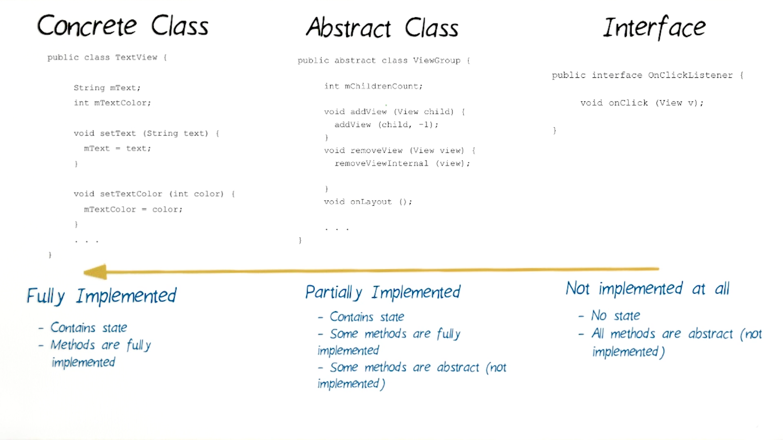

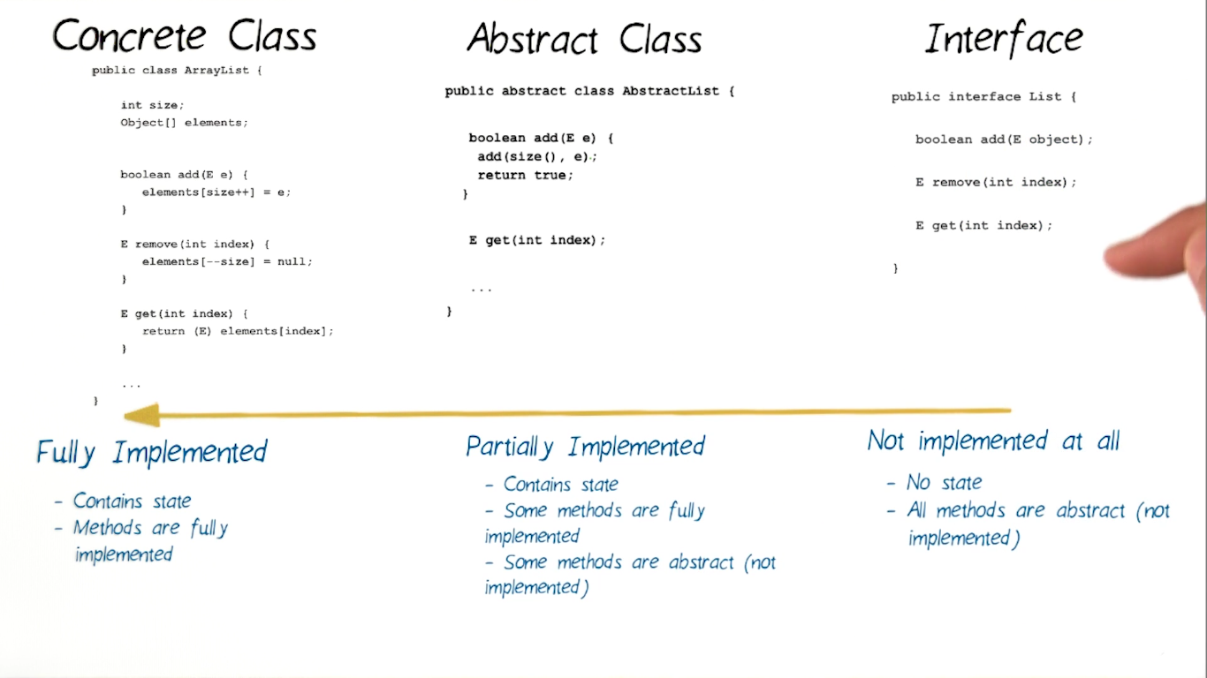

**ArrayList**

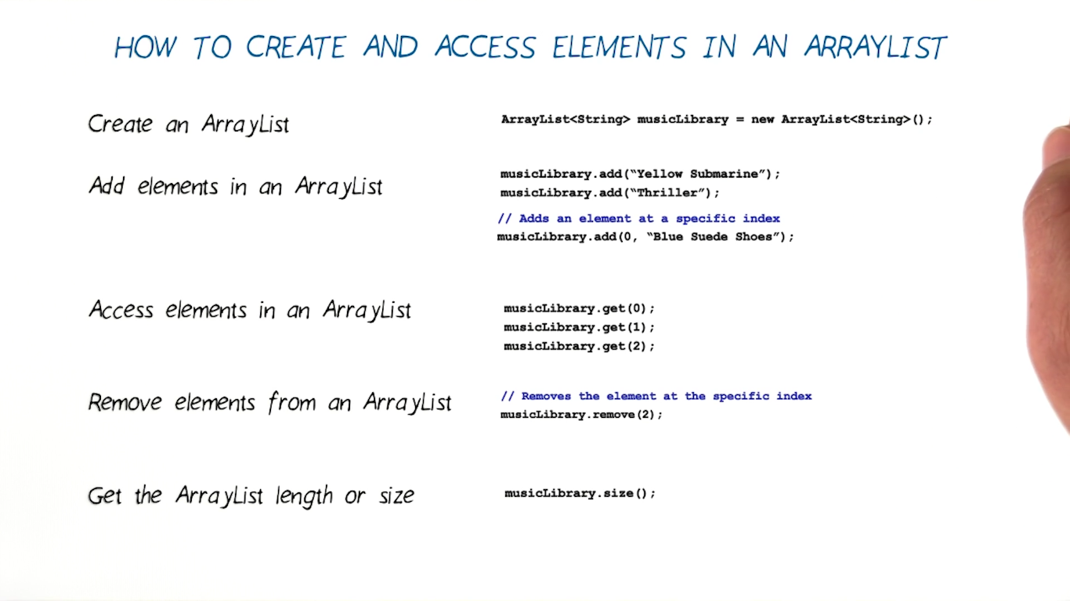

**GCE Garbage Collection Event**

**ArrayAdapter**

**ArrayAdapter<String> itemsAdapter = new ArrayAdapter<String>(this, android.R.layout.simple_list_item_1, words);**

**ListView listView = (ListView) findViewById(R.id.list);**

**listView.setAdapter(itemsAdapter);**

**Custom Adapter**

**Word contain structure words default language and other or images etc..**

**WordAdapter extends ArrayAdapter<Word> and override getView method**

**ArrayList<Word> words= new ArrayList<Word>();  
words.add(new Word("one","lutti"));**

**WordAdapter adapter = new WordAdapter(this,words); // consider as ArrayAdapter but customized for usage  
ListView listView = (ListView) findViewById(R.id.*list*);  
listView.setAdapter(adapter);**

**public class WordAdapter extends ArrayAdapter<Word> {  
  
 public WordAdapter(@NonNull Context context, ArrayList resource) {  
 super(context, 0,resource);  
 }  
 @Override  
 public View getView(int position, View convertView, ViewGroup parent) {  
  
 // Check if the existing view is being reused, otherwise inflate the view  
 View listItemView = convertView;  
 if(listItemView == null) { //list_item.xml this have two text view content that you want  
 listItemView = LayoutInflater.*from*(getContext()).inflate(R.layout.*list_item*, parent, false);  
 }  
 Word local_word = getItem(position);  
 TextView miwokTextView = (TextView) listItemView.findViewById(R.id.*miwok_text_view*);  
 miwokTextView.setText(local_word.getMiwokTranslation());  
 TextView defaultTextView = (TextView) listItemView.findViewById(R.id.*default_text_view*);  
 defaultTextView.setText(local_word.getDefaultTranslation());  
  
 return listItemView;  
 }  
}**

**UNIX ->** Uniplexed Information and Computer Systems.

It was called Multics for Multiplexed Information and Computing System. Unix was named after multics and was intended as sort of an insult since Multics had become too complex

**Note drawable name must be lowercase,0-9 or underscore**

**Media Player States**

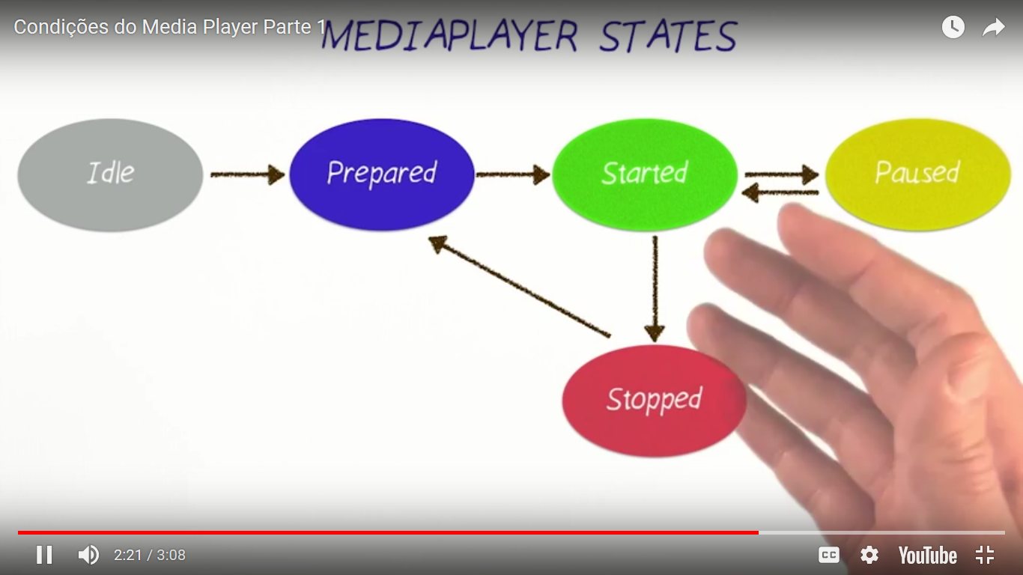

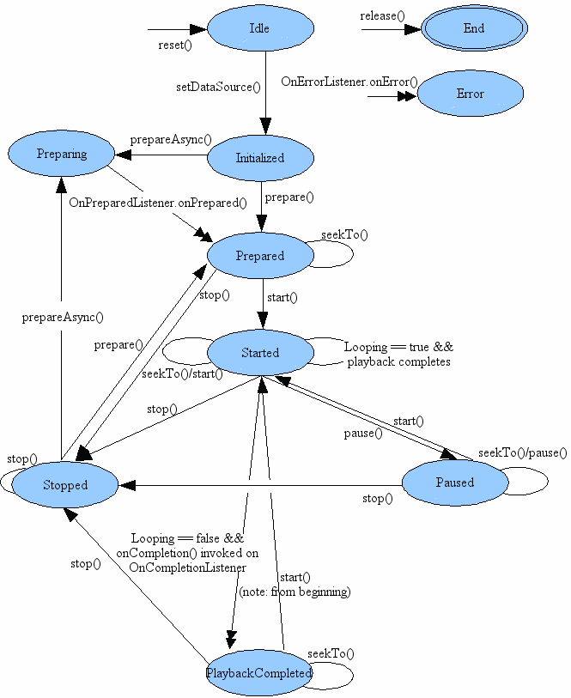

**Note**

**When you use image in app you must past It inside android studio IDE not in explorer file be careful**

**AdapterView**

* **ListView**
* **GiridView**
* **Spinner**
* **Gallery**

**setOnClickListener Vs setOnItemClickListener // note difference between them**

**final TextView colorsTextView = (TextView) findViewById(R.id.*colors*);  
colorsTextView.setOnClickListener(new View.OnClickListener() {  
 @Override  
 public void onClick(View view) {  
 Intent intentColor = new Intent(colorsTextView.getContext(),ColorsActivity.class);  
 startActivity(intentColor);  
 }  
});**

**listView.setOnItemClickListener(new AdapterView.OnItemClickListener() {  
 @Override  
 public void onItemClick(AdapterView<?> adapterView, View view, int i, long l) {  
 Toast.*makeText*(getApplicationContext(),"Clicked",Toast.*LENGTH_SHORT*).show();  
 }  
});**

**----------------**

**mediaPlayer.setOnCompletionListener(new MediaPlayer.OnCompletionListener() {  
 @Override  
 public void onCompletion(MediaPlayer mediaPlayer) {  
 Toast.*makeText*(getApplicationContext(),R.string.*amen*,Toast.*LENGTH_SHORT*).show();  
 }  
});**

**Synchronous vs Asynchronous (Async callback)**

**(Async callback) like onItemClickListener and OnClickListener**

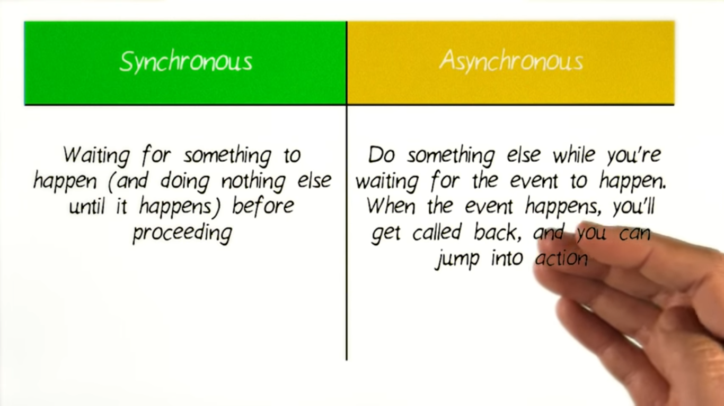

**Android Activity Lifecycle**

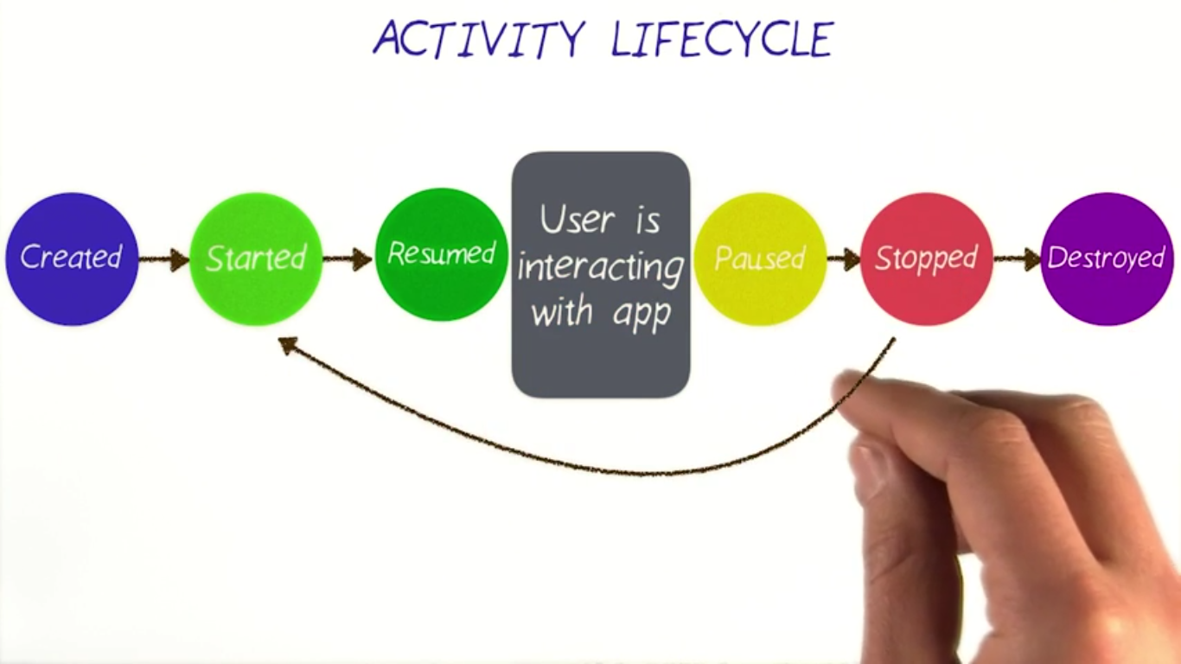

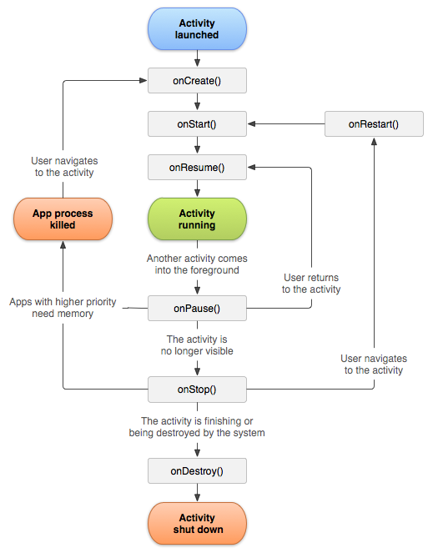

**Activity has six states**

* *Created*
* *Started*
* *Resumed*
* *Paused*
* *Stopped*
* *Destroyed*

**Activity lifecycle** has seven methods

* onCreate()
* onStart()
* onResume()
* onPause()
* onStop()
* **onRestart()**
* onDestroy()

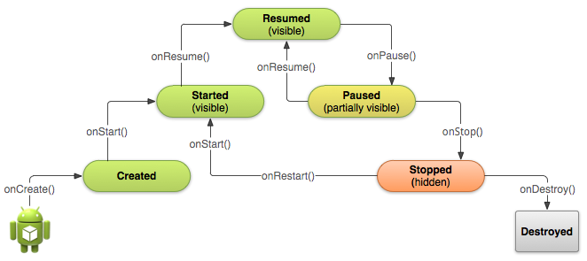

**Situations**

* **When open the app**

**onCreate() --> onStart() --> onResume()**

* **When back button pressed and exit the app**

**onPaused() -- > onStop() --> onDestory()**

* **When home button pressed**

**onPaused() --> onStop()**

* **After pressed home button when again open app from recent task list or clicked on icon**

**onRestart() --> onStart() --> onResume()**

* **When open app another app from notification bar or open settings**

**onPaused() --> onStop()**

* **Back button pressed from another app or settings then used can see our app**

**onRestart() --> onStart() --> onResume()**

* **When any dialog open on screen**

**onPause()**

* **After dismiss the dialog or back button from dialog**

**onResume()**

* **Any phone is ringing and user in the app**

**onPause() --> onResume()**

* **When user pressed phone's answer button**

**onPause()**

* **After call end**

**onResume()**

* **When phone screen off**

**onPaused() --> onStop()**

* **When screen is turned back on**

**onRestart() --> onStart() --> onResume()**

**Audio Focus States**

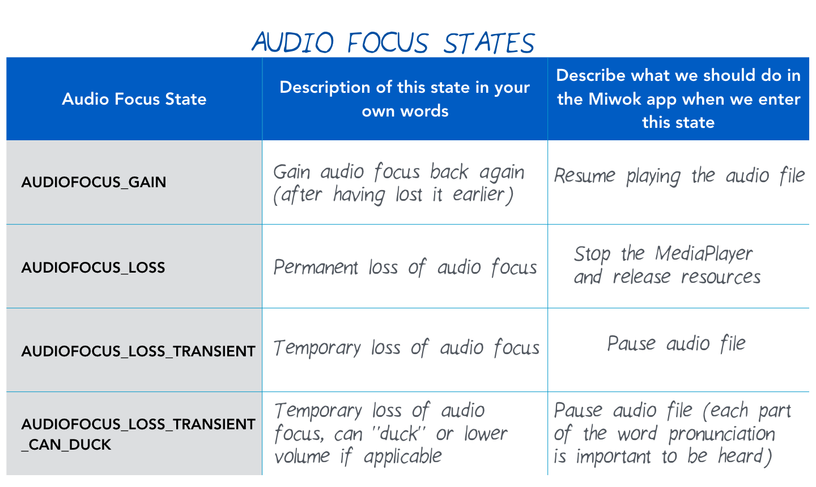

**In ListView you can put this to make feedback effect pressed state for ListItem**

**android:drawSelectorOnTop="true"**

**in View you can do that for touch feedback for clickable view in View**

android:background="?android:attr/selectableItemBackground"